Hosting Packet

Hosting School Setup Checklist
Please have everything set up at least an hour prior to game start.

- Download/print Officials Packet (ref score book & scoresheets)
- Athletic Trainers secured with emergency plan in place
- Game floor set up per the following diagram
- 9 strips for the floor, 2 strips on each side for warmup
- White Velcro/white tape strips separating the neutral area
- Measured hash marks
- Chairs for team benches (20 chairs for each team)
- Water stations for each bench
- Operational scoreboard or flip card scoreboard
- Music downloaded and ready to play
- Microphone for announcer
- Walkie Talkie setup for referee and head official
- Sound system and music tested
- Officials’ video equipment for routine review (if available)

Game Floor Layout

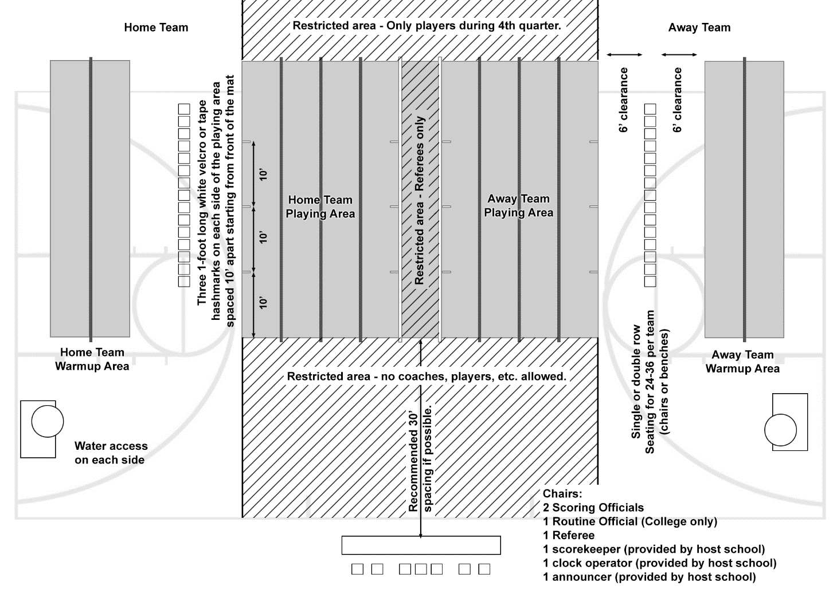

For High School games, if there is a shortage of mats, the following steps can be taken:
- Remove the center strip but leave the 6’ spacing between sides.
- Only provide one warmup mat strip on each side.
- Remove warmup mat strips and allow additional time to warm up before the game and quarters on the team’s side of the matted floor.
Announcer Script
There are three sections provided for the announcer; a pregame script, a sample script of what to do throughout the game, and a list of additional announcements. Please read carefully prior to the game start and let the game director know if you have any questions.

Announcer: Pregame
5 minutes prior to game start – As soon as the coaches & captains take the floor. WELCOME THE CROWD AND READ THE FOLLOWING:
Good Evening Ladies & Gentlemen, and welcome to today’s STUNT game here at _________________________________.
Today’s event features the new women’s varsity sport format called “STUNT.” USA Cheer is the national governing body for all things related to cheerleading, and has developed this new and exciting sport created from the athletic skills of traditional and competitive cheer.

STUNT has been presented to the NCAA for consideration as a new NCAA Women’s Varsity Sport. Once accepted by the NCAA, STUNT will offer tremendous athletic and academic opportunities at the collegiate level for thousands of female athletes with a highly trained cheerleading background.

A STUNT game will feature 4 quarters of competition:
- 1st quarter = Partner Stunts
- 2nd quarter = Pyramids & Tosses
- 3rd quarter = Group Jumps & Tumbling
- 4th quarter = Combined Team Performance
In each of the first 3 quarters, there are 4 rounds of competition. In each round, teams will perform 1 of 6 (7 for college) pre-choreographed routines head to head on the competition floor. The team with possession in each round will determine which routine is performed.
The judges will rank the teams at the end of each round based on the execution of the performances.
- The team with the best execution wins the round and will be awarded 1 point.
- The team that loses the round will not receive any points.
- In the case of a tie, both teams will be awarded 1 point.
- A team may forfeit a round if they are unable to perform the necessary skills in a routine. Should a team “Forfeit”, then that team will receive zero points for that round, but also regain possession.
- The team with the highest point total at the end of the 4th quarter will be declared the Winner.
We appreciate your attendance, and thank you for your support of these athletes and the new sport they represent.
PAUSE FOR A FEW SECONDS AND THEN START TEAM INTRODUCTIONS
Today’s game will feature the following STUNT Teams: (read however you want)
Team: _______________________________
City: _______________________________
Mascot: _______________________________
Head Coach: _______________________________
Team: _______________________________
City: _______________________________
Mascot: _________ ______________________
Head Coach: _______________________________
PAUSE FOR A FEW SECONDS AND THEN CUE THE NATIONAL ANTHEM
Now Ladies and Gentlemen, please rise, remove your hats, and join in the singing of our National Anthem.
REFEREE THEN ANNOUNCES WHO WON POSSESSION AND STARTS GAME.
Announcer: During Game
After each round, announce who won and the points awarded. You may say this however you want and change it up as you go.
The _________________________wins the first round of the partner stunt quarter and receives 1 point. The score is now ___ to ___.
- Periodically give the total game score along with who wins the round points.
- During the quarter breaks announce the total game score and explain the next quarter.
Ladies and Gentlemen, that concludes the ___ quarter of today’s game. _________________ pulls ahead with a score of ___ and _________________ is close behind in second with a score of ___. We will take a 2 minute quarter break and then start the ___ quarter, ___(quarter name)___.
- During quarter breaks, please read announcements from the provided list of additional Announcements.

Game Timeline
1st Quarter – Partner Stunts (4 rounds)
2 Minute quarter break
2nd Quarter – Pyramids and Tosses (-4 rounds)
6 - 10 Minute Halftime (depending on coach agreement)
3rd Quarter – Group Jumps and Tumbling (4 rounds)
2 Minute quarter break
4th Quarter – Team Routine (3 rounds)
BEFORE THE 4th QUARTER ANNOUNCE:
In the 4th quarter, teams will be performing a combined routine with three segments. There are three rounds in this quarter, and the scoring is as follows:
- Teams are awarded points for each of the 3 segments of each round.
- Depending on which team wins each segment, each team may score up to three points for each round.
IN THE EVENT OF A FORFEIT DURING THE 4th QUARTER, OR A TIE AT THE END OF THE GAME, READ THE EXPLANATION BELOW RESPECTIVELY.
- 4th Quarter Forfeit = 0 points are awarded to the forfeiting team. If the opposing team then performs, the scoring officials will award 0-3 points based on the teams execution of the performance.
- Ties = If the game ends in a tie, there will be a sudden death overtime. Teams will draw for possession, and the team with possession will select a quarter. Routine #1 will be performed by both teams. If still a tie, the other team will select the next quarter, and routine #2 of that quarter will be performed. This will continue until a team wins a round, thus winning the game.

Additional Announcements
- Want to learn more about STUNT? Visit usacheer.org for more information!
- Stay up to date on all things STUNT! Follow STUNT on twitter, Instagram, and facebook @stuntthesport
- 2019 is the 9th season of the sport of STUNT. Over 40 teams are participating at the college level this season. The college season will conclude May 3-5 at the University of Oklahoma at the College STUNT National Championship.
- There are over 100 high school teams playing STUNT seasons this spring, throughout Oklahoma, California, New York, North Carolina, Florida, Kentucky, and several others! Visit usacheer.org to find out more!

- Concessions
- Upcoming games

- Other local announcements

Score and Timekeeping Guide
(2 Team Game using Basketball Scoreboard)
SCORING
Quarters 1-3
Watch the floor referee. They will signal which team wins the round in the 1st, 2nd, and 3rd quarters.
Winner of each round receives 1 point, losing team receives 0 points
Ties - Both teams receive 1 point (possession alternates)
4th Quarter
Watch the floor referee. They will signal which team wins the round and how many points each team gets. This is slightly different from the first three quarters.
Each team will receive up to 3 points per round as determined by the Scoring Officials and indicated by the Referee. For example, a 4th quarter round could result in a 2-1 score, a 3-0 score, or a 1-3 score, depending on which team won or tied each of the three segments of the routine. It could even be a 3-3 score if the teams tied each of the segments.
Overtime
Overtime scoring is based on which quarter is selected by the team with possession. If they choose Quarters 1 – 3, follow Quarter 1-3 scoring above. If they choose the 4th Quarter, use the 4th Quarter scoring above.
Forfeits
Forfeiting team = 0 points and regains possession (unless it’s the last round of the quarter).
Team that doesn’t forfeit must perform in order to get points. The officials will decide if the performing team gets 0 or 1 point in quarter 1 through 3, and 0-3 points in quarter 4 based on the execution of the routine. A team can forfeit just one segment of the routine for the 4th quarter.
TIME KEEPING
Quarter Breaks = 2 minutes on the game clock
(between 1st and 2nd quarters, between 3rd and 4th quarters)
Halftime = 10 minutes on the game clock
Timeouts = 1 minute on the game clock
Each team receives three timeouts per game.
POSSESSION ARROW

The referee will designate which team has possession. Use of the possession arrow is not necessary, but may be helpful to the referee.
In STUNT, “possession” means your team gets to call which routine will be performed in the round. It plays to your strength or the other team’s weakness.
The home team calls the opening coin toss. The team that wins the coin toss can choose to start the game with possession or defer to the 2nd half for possession. If they defer, the other team gets possession and chooses which routine will be played first.
To start the 2nd and 4th quarter, the team with the lowest score gets possession, regardless of what happened in the previous rounds.
Within a quarter, whoever wins the round gets possession (make it, take it).
If the round ends in a tie, possession alternates to the other team.
In the event of a forfeit, the forfeiting team gets possession.
In overtime, the visiting team calls the coin toss. Winner gets possession. From there on, possession alternates for each new overtime round.

